

Functional Safety Concept Lane Assistance

**Document Version: [0.1]**



# Document history

|  |  |  |  |
| --- | --- | --- | --- |
| Date | Version | Editor | Description |
| 24.08.2017 | 0.1 | Aneeq Mahmood | Functional safety description |
|  |  |  |  |
|  |  |  |  |
|  |  |  |  |
|  |  |  |  |

# Table of Contents

Document history

Table of Contents

Purpose of the Functional Safety Concept

Inputs to the Functional Safety Analysis

Safety goals from the Hazard Analysis and Risk Assessment

Preliminary Architecture

Description of architecture elements

Functional Safety Concept

Functional Safety Analysis

Functional Safety Requirements

Refinement of the System Architecture

Allocation of Functional Safety Requirements to Architecture Elements

Warning and Degradation Concept

# Purpose of the Functional Safety Concept

**[Instructions: Answer what is the purpose of a functional safety concept?]**

Functional safety concept (FSC) takes safety requirements arising from hazard analysis and risk assessment, and set goals within the system architecture to overcome the potential hazards and make the whole process safer. FSC incorporates changes at a higher level and does not deal with technical specifications for bringing about the required changes to the system architecture.

# Inputs to the Functional Safety Concept

## Safety goals from the Hazard Analysis and Risk Assessment

**[Instructions:**

**REQUIRED:**

**Provide the lane departure warning and lane keeping assistance safety goals as discussed in the lessons and derived in the hazard analysis and risk assessment.**

**]**

|  |  |
| --- | --- |
| **ID** | **Safety Goal** |
| Safety_Goal_01 | The oscillating steering from torque from the lane departure warning (LDW) function should be limited |
| Safety_Goal_01 | The lane keeping assistance (LKA) function shall be time limited and the additional steering torque shall end after a given timer interval so that the driver cannot misuse the system for autonomous driving |

## Preliminary Architecture

**[Instructions: Provide a preliminary architecture for the lane assistance item. Hint: See Lesson 3: Item Definition]**

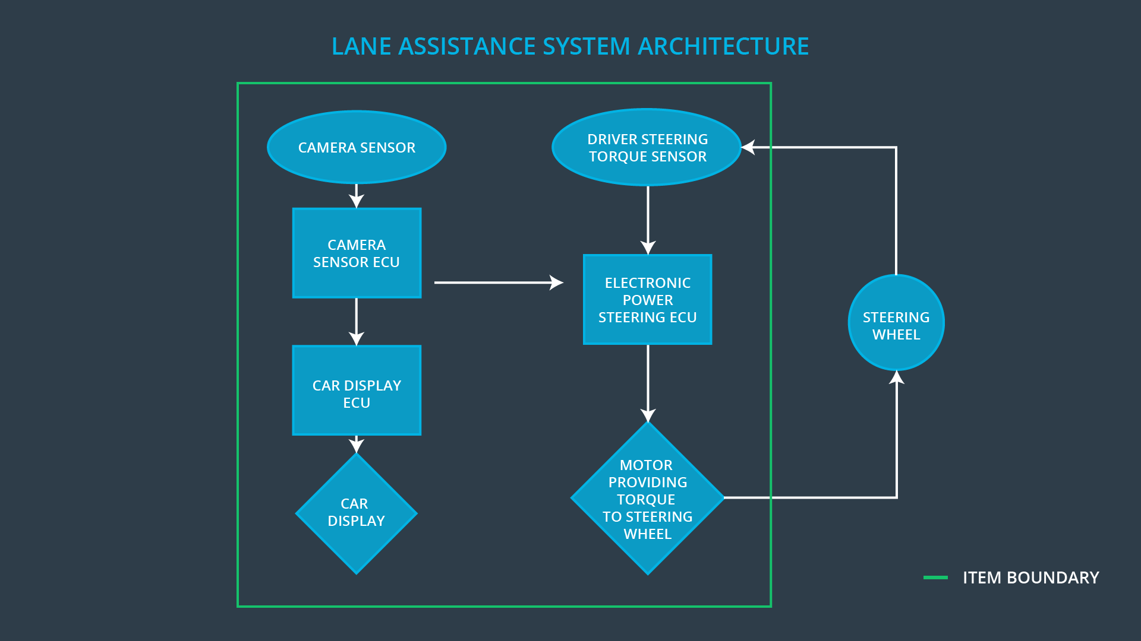

### Description of architecture elements

**[Instructions: Provide a description for each of the item elements; what is each element's purpose in the lane assistance item? ]**

|  |  |
| --- | --- |
| **Element** | **Description** |
| Camera Sensor | Captures the road and sends the captured frames to the camera sensor ECU |
| Camera Sensor ECU | Using the information from the camera sensor, it determines the lane boundaries and notifies the car display system and power steering ECU if the car leaves the lane |
| Car Display ECU | Takes input form camera ECU and control the logic for activating or deactivating LEDs showing the status of LKA and LDW at car display |
| Car Display | Takes the input from car display ECU to turn the LEDS  Off or On |
| Driver Steering Torque Sensor | Measures the torque coming from the driver |
| Electronic Power Steering (EPS) ECU | Takes input from camera ECU and current driver torque sensor to compute necessary torque for LKA, and assesses the torque amplitude and frequency for LKA |
| Motor | Takes its input from the EPS ECU and responsible for providing torque to the steering wheel and also |

# Functional Safety Concept

The functional safety concept consists of:

* Functional safety analysis
* Functional safety requirements
* Functional safety architecture
* Warning and degradation concept

## Functional Safety Analysis

**[Instructions: Fill in the functional safety analysis table below.]**

|  |  |  |  |
| --- | --- | --- | --- |
| **Malfunction ID** | **Main Function of the Item Related to Safety Goal Violations** | **Guidewords (NO, WRONG, EARLY, LATE, MORE, LESS)** | **Resulting Malfunction** |
| Malfunction_01 | Lane Departure Warning (LDW) function shall apply an oscillating steering torque to provide the driver a haptic feedback | MORE | The lane departure warning function applies an oscillating torque with very high torque amplitude (above limit)" |
| Malfunction_02 | Lane Departure Warning (LDW) function shall apply an oscillating steering torque to provide the driver a haptic feedback | MORE | The lane departure warning function applies an oscillating torque with very high torque freqeuncy (above limit)" |
| Malfunction_03 | Lane Keeping Assistance (LKA) function shall apply the steering torque when active in order to stay in ego lane | NO | The LKA function is not limited in time duration which leads to misuse as an autonomous driving function |

## Functional Safety Requirements

**[Instructions: Fill in the functional safety requirements for the lane departure warning ]**

Lane Departure Warning (LDW) Requirements:

|  |  |  |  |  |
| --- | --- | --- | --- | --- |
| **ID** | **Functional Safety Requirement** | **ASIL** | **Fault Tolerant Time Interval** | **Safe State** |
| Functional  Safety  Requirement  01-01 | The EPS ECU shall ensure that the oscillating torque amplitude is below  Max_Torque_Amplitude | C | 50 ms | Off |
| Functional  Safety  Requirement  01-02 | The EPS ECU shall ensure that the oscillating torque amplitude is below  Max_Torque_Frequency | C | 50 ms | Off |

Lane Departure Warning (LDW) Verification and Validation Acceptance Criteria:

|  |  |  |
| --- | --- | --- |
| **ID** | **Validation Acceptance**  **Criteria and Method** | **Verification Acceptance**  **Criteria and Method** |
| Functional  Safety  Requirement  01-01 | After fixing a limit on Max_Torque_Amplitude, test will be done to see how drivers react to different torque to prove that an appropriate value has been chosen | When the torque magnitude  becomes greater than Max_Torque_Amplitude, the LKA system’s output  is set to zero within the 50 ms fault tolerant  time interval |
| Functional  Safety  Requirement  01-02 | After fixing a limit on Max_Torque_Frequency, test will be done to see how drivers react to different torque frequencies to prove that an appropriate value has been chosen | When the torque frequency  becomes greater than Max_Torque_Frequency, the LKA system’s output  is set to zero within the 50 ms fault tolerant  time interval |

**[Instructions: Fill in the functional safety requirements for the lane keeping assistance]**

Lane Keeping Assistance (LKA) Requirements:

|  |  |  |  |  |
| --- | --- | --- | --- | --- |
| **ID** | **Functional Safety Requirement** | **ASIL** | **Fault Tolerant Time Interval** | **Safe State** |
| Functional  Safety  Requirement  02-01 | The EPS ECU shall ensure  that the LKA support is available for only Max_Duration | B | 500 ms | Off |

Lane Keeping Assistance (LKA) Verification and Validation Acceptance Criteria:

|  |  |  |
| --- | --- | --- |
| **ID** | **Validation Acceptance**  **Criteria and Method** | **Verification Acceptance**  **Criteria and Method** |
| Functional  Safety  Requirement  02-01 | Do tests to ensure that the max_duration chosen really did dissuade drivers from taking their hands off the wheel. | Verify that the system really does turn off if the lane keeping assistance every exceeded max_duration. |

## Refinement of the System Architecture

**[Instructions: Include the refined system architecture. Hint: The refined system architecture should include the system architecture from the end of the functional safety lesson including all of the ASIL labels.]**

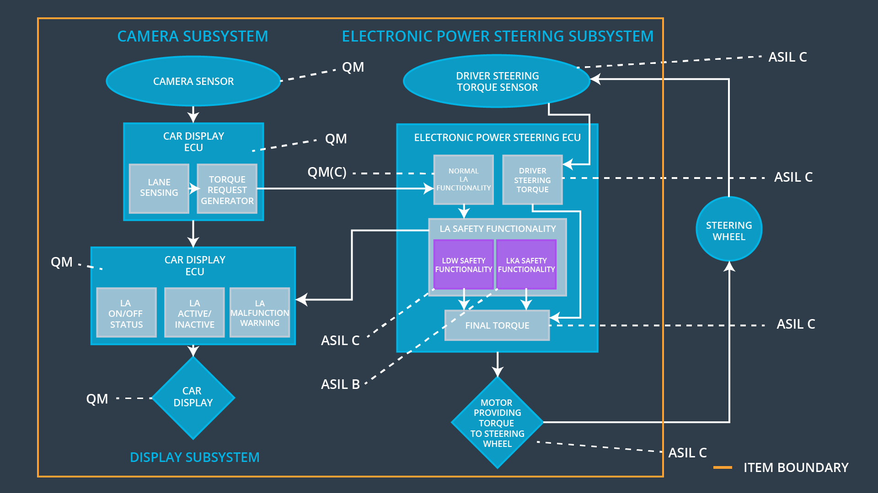

## 

## Allocation of Functional Safety Requirements to Architecture Elements

**[Instructions: Mark which element or elements are responsible for meeting the functional safety requirement.]**

|  |  |  |  |  |
| --- | --- | --- | --- | --- |
| **ID** | **Functional Safety Requirement** | **Electronic Power Steering ECU** | **Camera ECU** | **Car Display ECU** |
| Functional  Safety  Requirement  01-01 | The EPS ECU shall ensure that torque frequency for LDW shall not exceed amplitude  Max_Torque_Amplitude | **×** |  |  |
| Functional  Safety  Requirement  01-02 | The EPS ECU shall ensure that torque frequency for LDW shall not exceed frequency  Max_Torque_Frequency | **×** |  |  |
| Functional  Safety  Requirement  02-01 | The EPS ECU will ensure that the LKA function shall be time limited by making sure that the additional steering torque shall end after a given timer interval so that the driver cannot misuse the system for autonomous driving | **×** |  |  |

## Warning and Degradation Concept

**[Instructions: Fill in the warning and degradation concept.]**

|  |  |  |  |  |
| --- | --- | --- | --- | --- |
| **ID** | **Degradation Mode** | **Trigger for Degradation Mode** | **Safe State invoked?** | **Driver Warning** |
| WDC-01 | Off | Torque frequency or amplitude exceeds its maximum threshold i.e.,  Max_Torque_Amplitude or Max_Torque_Frequency | Yes | LED on Car Display |
| WDC-02 | Off | The LKA torque is being applied for more than max_duration | Yes | LED on Car Display |